Test Case ID
TC_001
Test Case Name
Search based on date filter
Test Scenario
User selected a valid date range and search for all logs types in all folders.

Preconditions
N/A
Test Steps
- Launch the application and select the valid FROM DATE and TO DATE
- Keep all other fields as default(all).
- Click a Search Button.

Expected Result
- verify it all displayed records fall within selected data range
2. Verify that records not matching the selected criteria are not displayed

Actual Result

- After selecting date range.

The records are displayed successfully based on the selected date range.
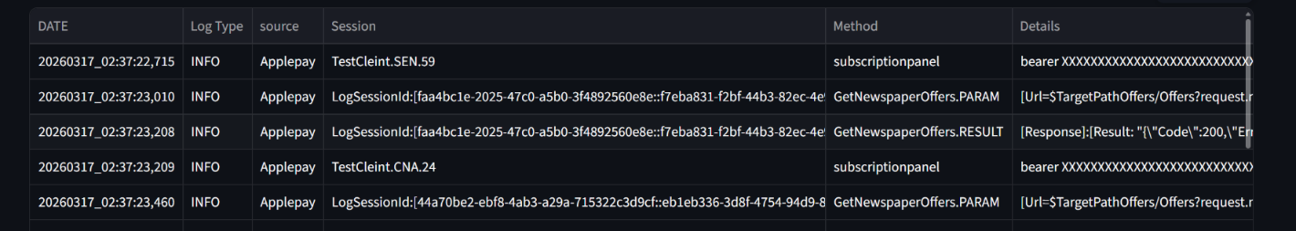

- After selecting date range

The records shows No records were found.



Test Case ID
TC_002
Test Case Name
Search based on date filter.
Test Scenario
User selected a invalid date range and search for all logs types in all folders.

Preconditions
N/A
Test Steps
1.Launch the application and select the valid FROM DATE and TO DATE
2.Keep all other fields as default(all).
- Click a Search Button.

Expected Result
1.verify it all displayed records fall within selected data range
2. Verify that records not matching the selected criteria are not displayed
3.verify that an error message is displayed when the “DATE FRPOM” value is greater than
“DATE TO” value.

Actual Result

1. After selecting “DATE FROM” value which is greater than the “DATA TO” value .

The records shows No records were found .


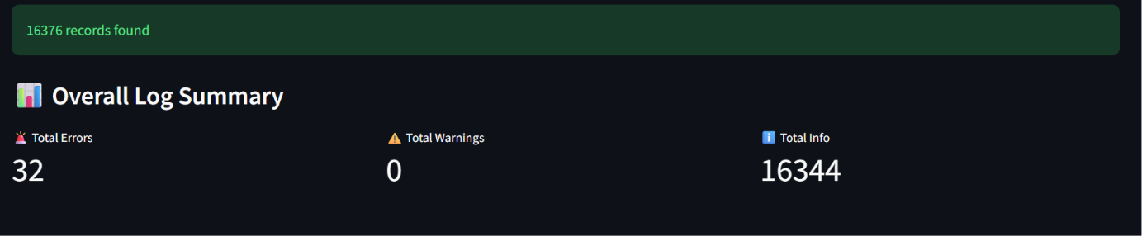

Test Case ID
TC_003
Test Case Name
Search based on Folder and Type Filter

Test Scenario
User selected folder and types and search for logs types in folders.

Preconditions
N/A

Test Steps
1.Launch the application and select the valid DATE FROM and DATE TO.
2. Select Folders and Types filter.
3.Click a Search Button.

Expected Result
1.verify it all displayed the records are displayed successfully based on the selected Folder Type and Type filter.

Actual Result
- After selecting a folder and a type .
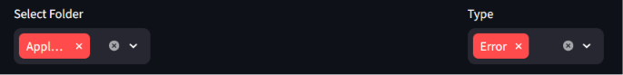
The records are displayed successfully based on the selected Folder Type and Type filter.
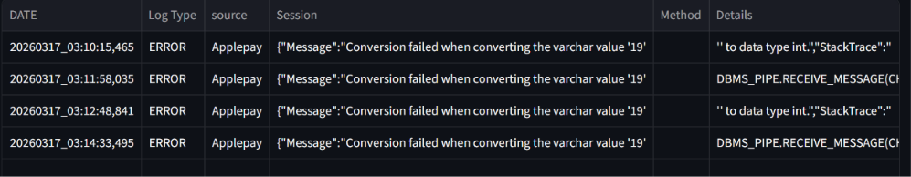

- After selecting a Folder and a Type .
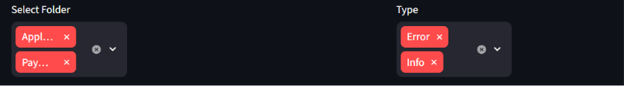
The records are displayed successfully based on multiselecting Folder Type and Type filter.
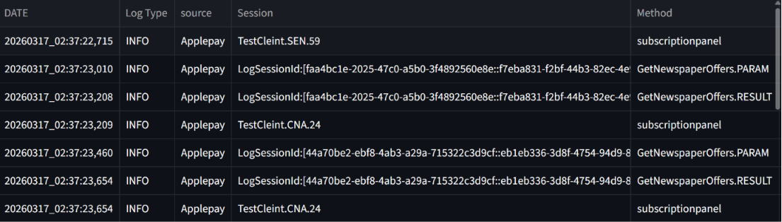

3. After selecting a Folder and a Type .
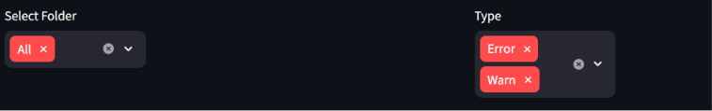
The records are displayed successfully based on Selecting all Folder and multiselect Type filter. 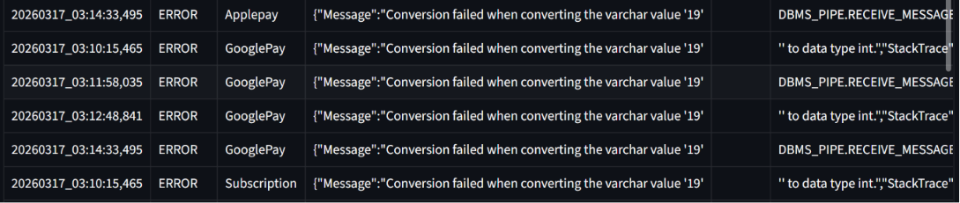

4. After selecting a Folder and a Type .
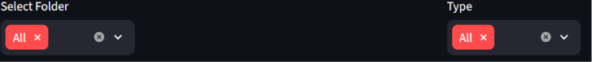
The records are displayed successfully based on Selecting all Folder and all Type filter.
